Capstone Project: Food Delivery System App  
Author: Rogelio Lotho

**Goal**: To Host the Application on AWS EC2 Instance, Automate the build and deployment using Jenkins on AWS EC2 and Containerize the application using Docker on AWS EC2

**Objective**: To build a dynamic and responsive food delivery app to display food items, filter based on user preferences, manage orders, user details.

**Tech Stack**: Angular, Java, SpringBoot, MySQL, Jenkins, Docker, AWS, Git and GitHub

1. Task 1. Angular Compoments, Routing, Services and AuthGuard, Forms
   1. Components: Cart, Administrator, Cuisines, Customers, Home, Login, Navbar, Orders, Password, Payment, Register  
      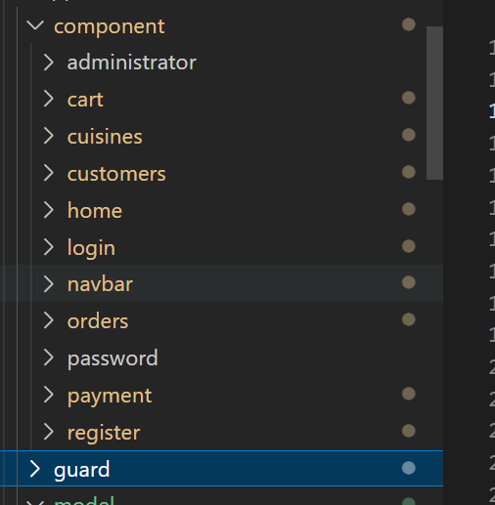
   2. Routing  
      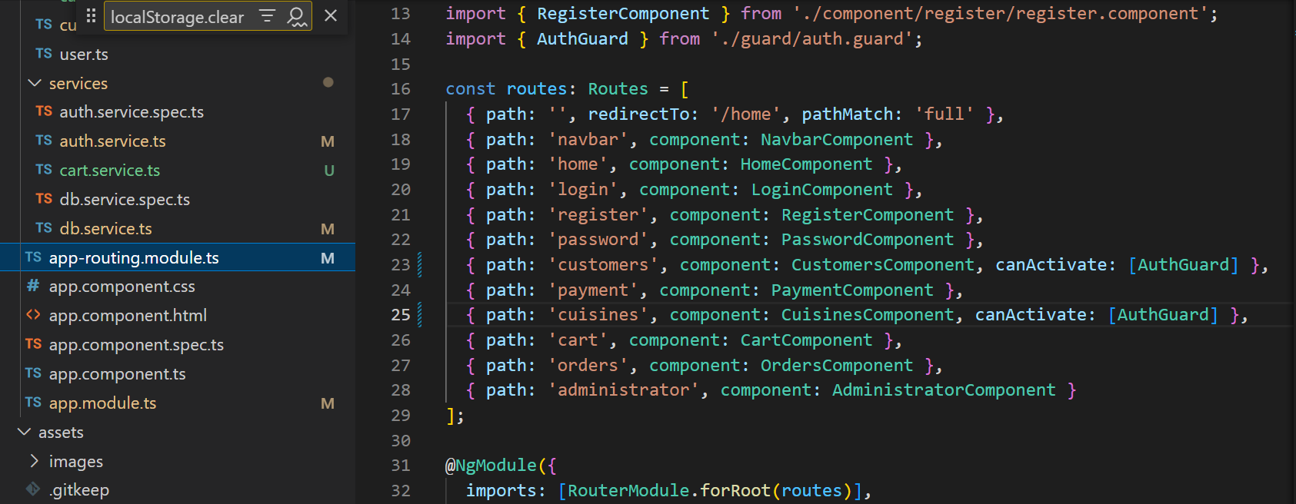
   3. Services  
       1.3.1 dbService  
       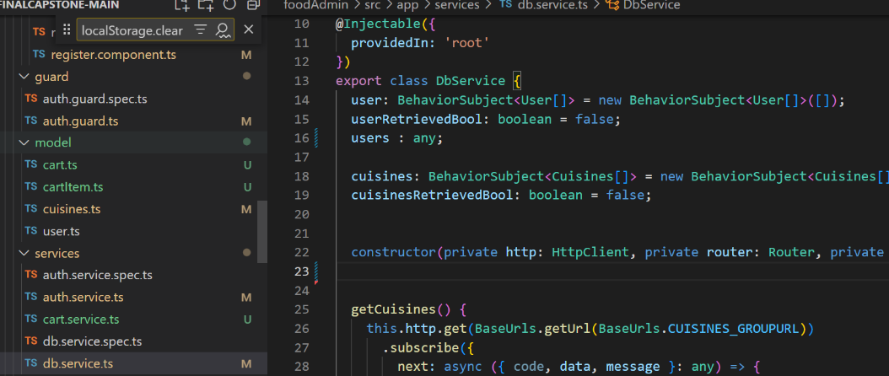
      1. Cart Service

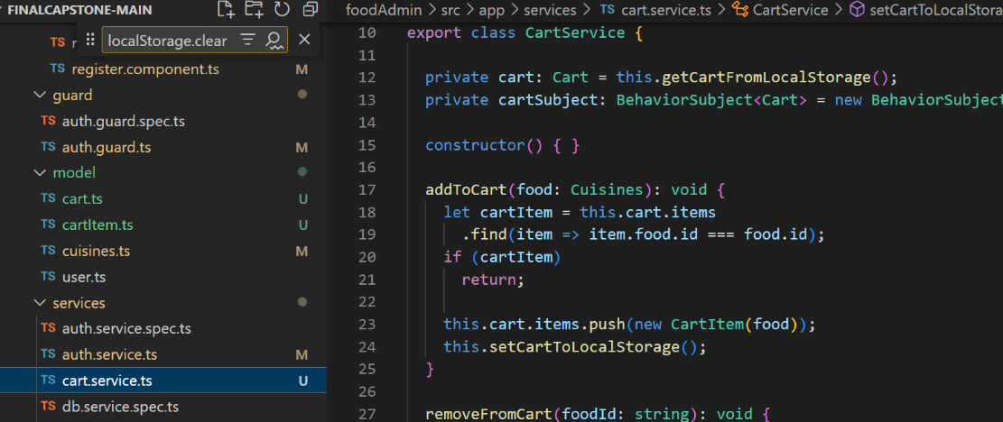

1.3.3 Auth Service

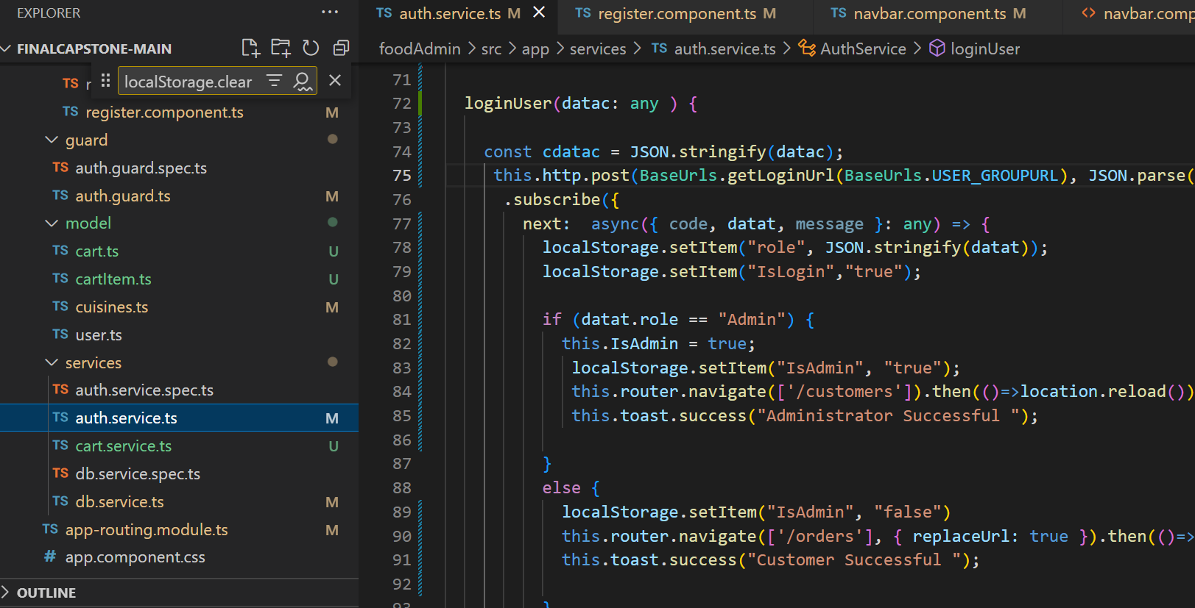

* 1. AuthGuard  
     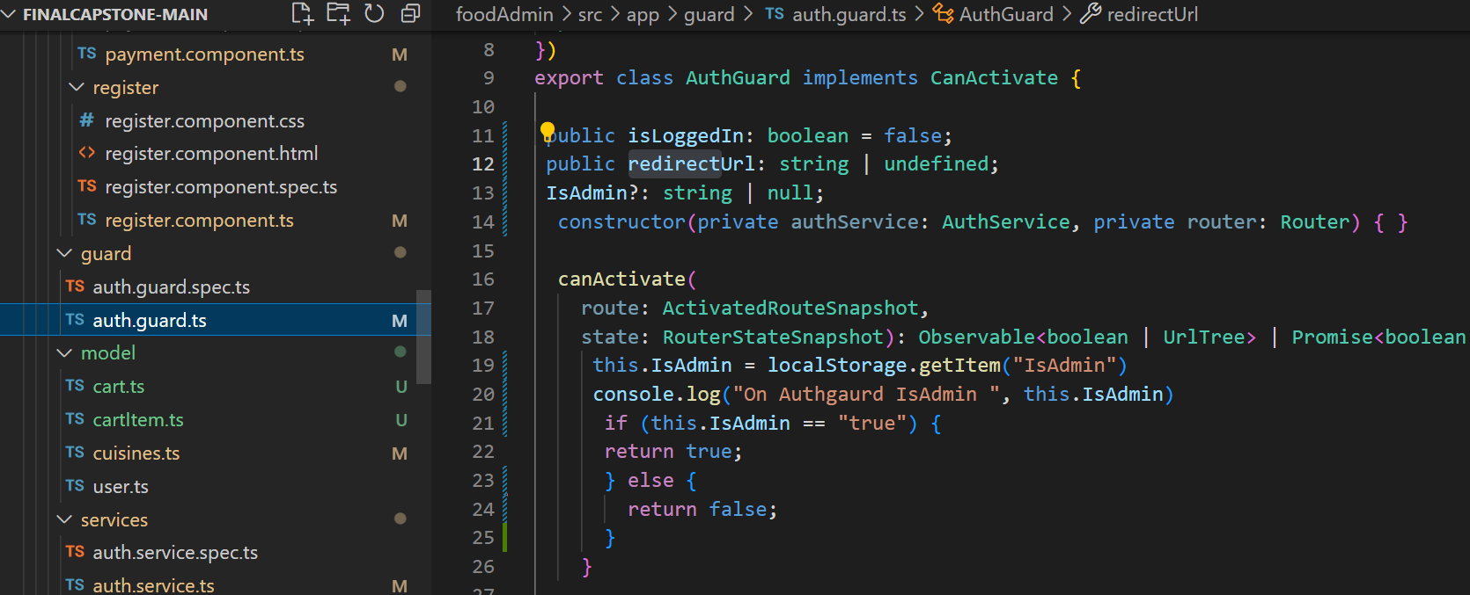
     1. Form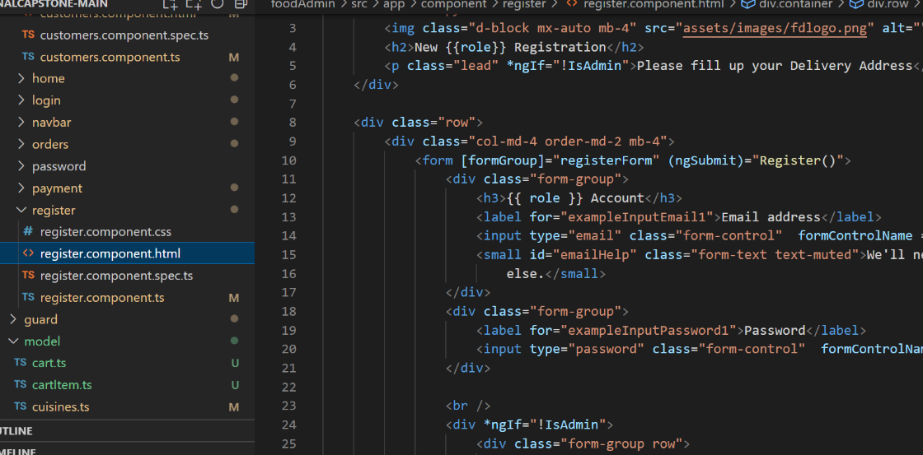
  2. Task 2 Angular Components, Routing, Services, and Auth Guard, Forms  
     2.1 App Routing Module  
     . 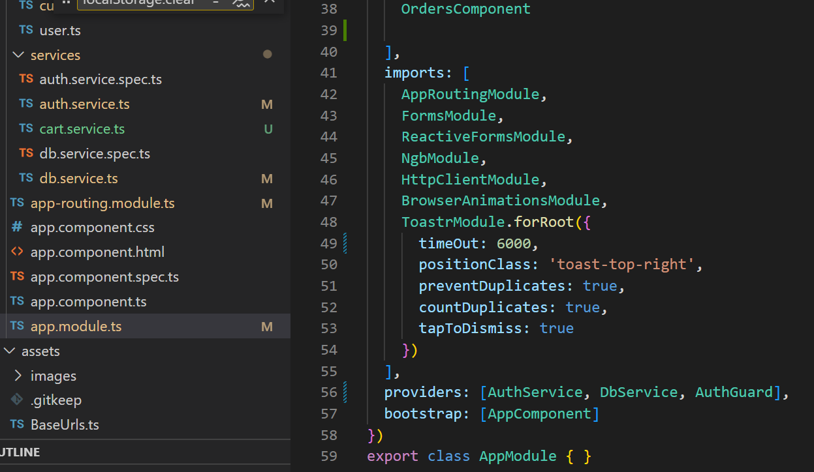

2.2. Home Component  
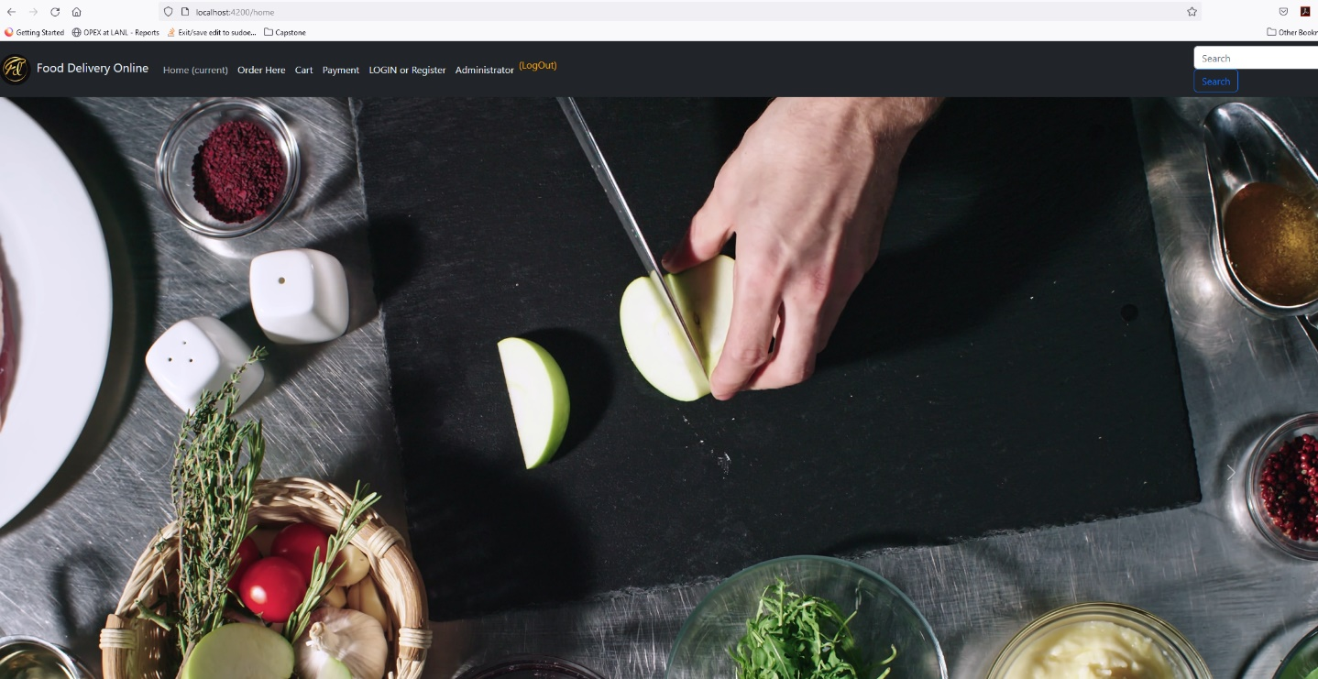

2.3 Order Component 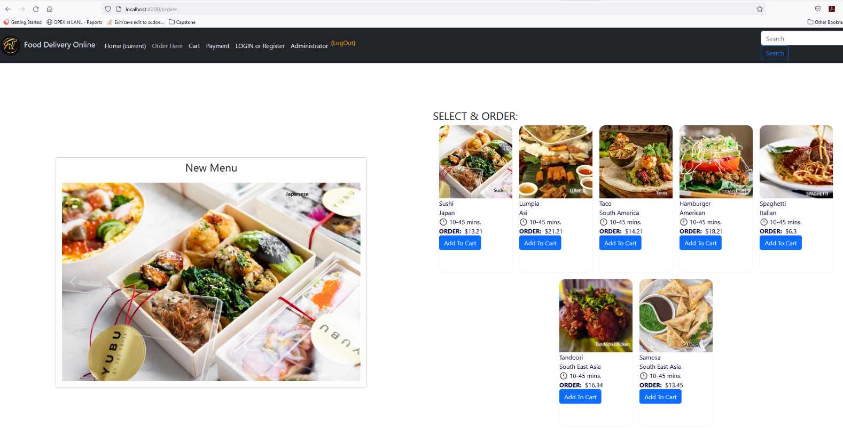

2.4. Cart Component

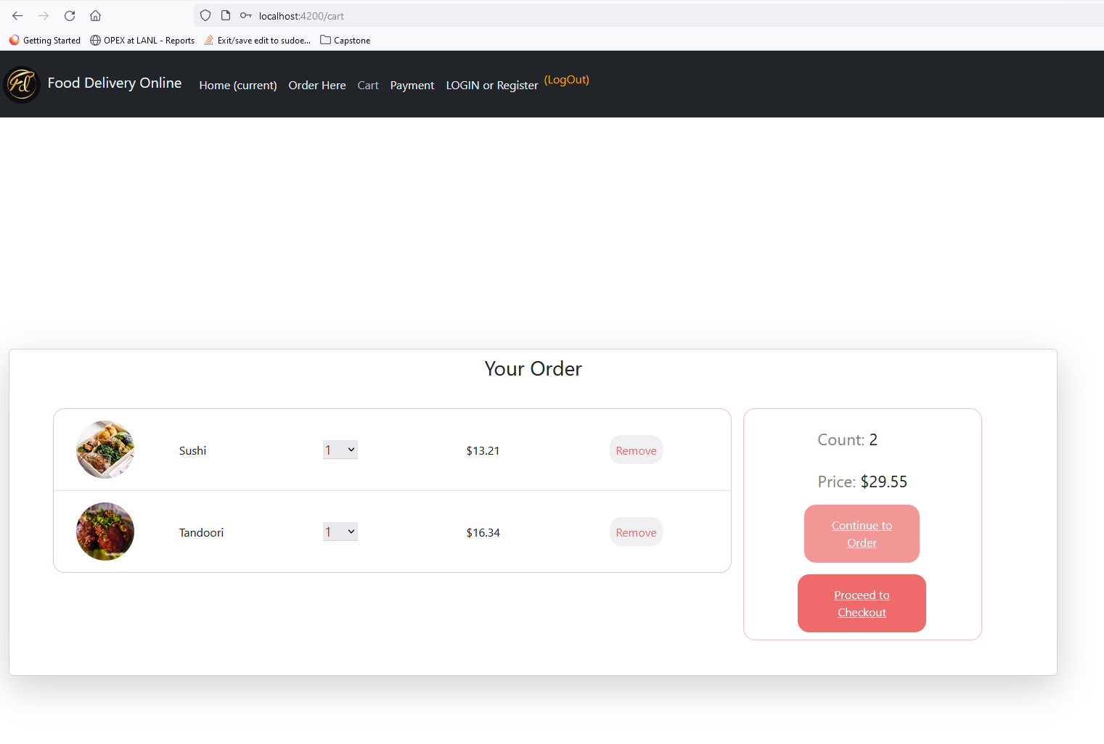

2.5 Payment Component  
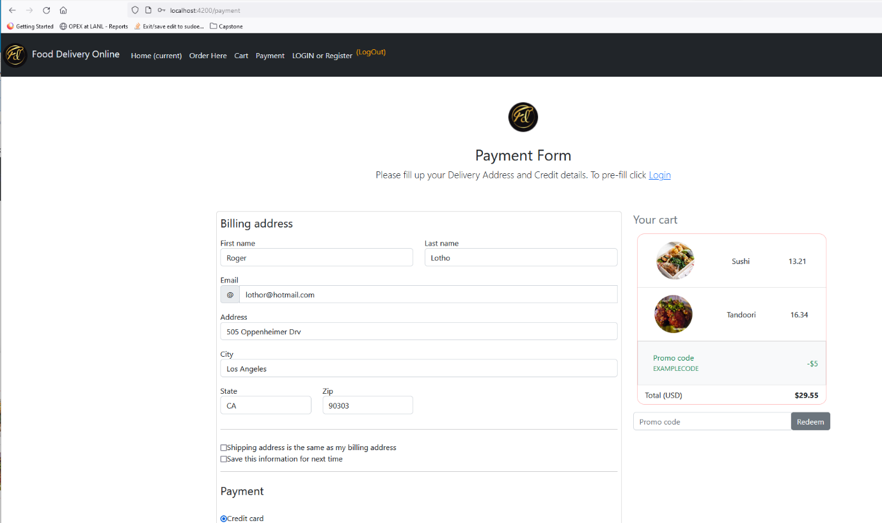

2.6. Login Component

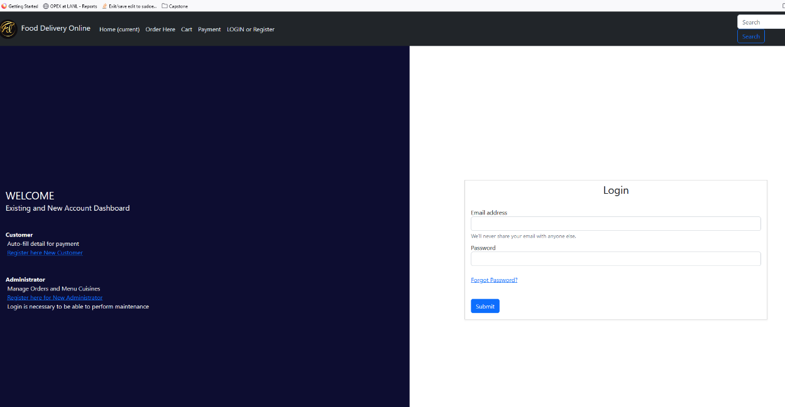

2.7. Register Customer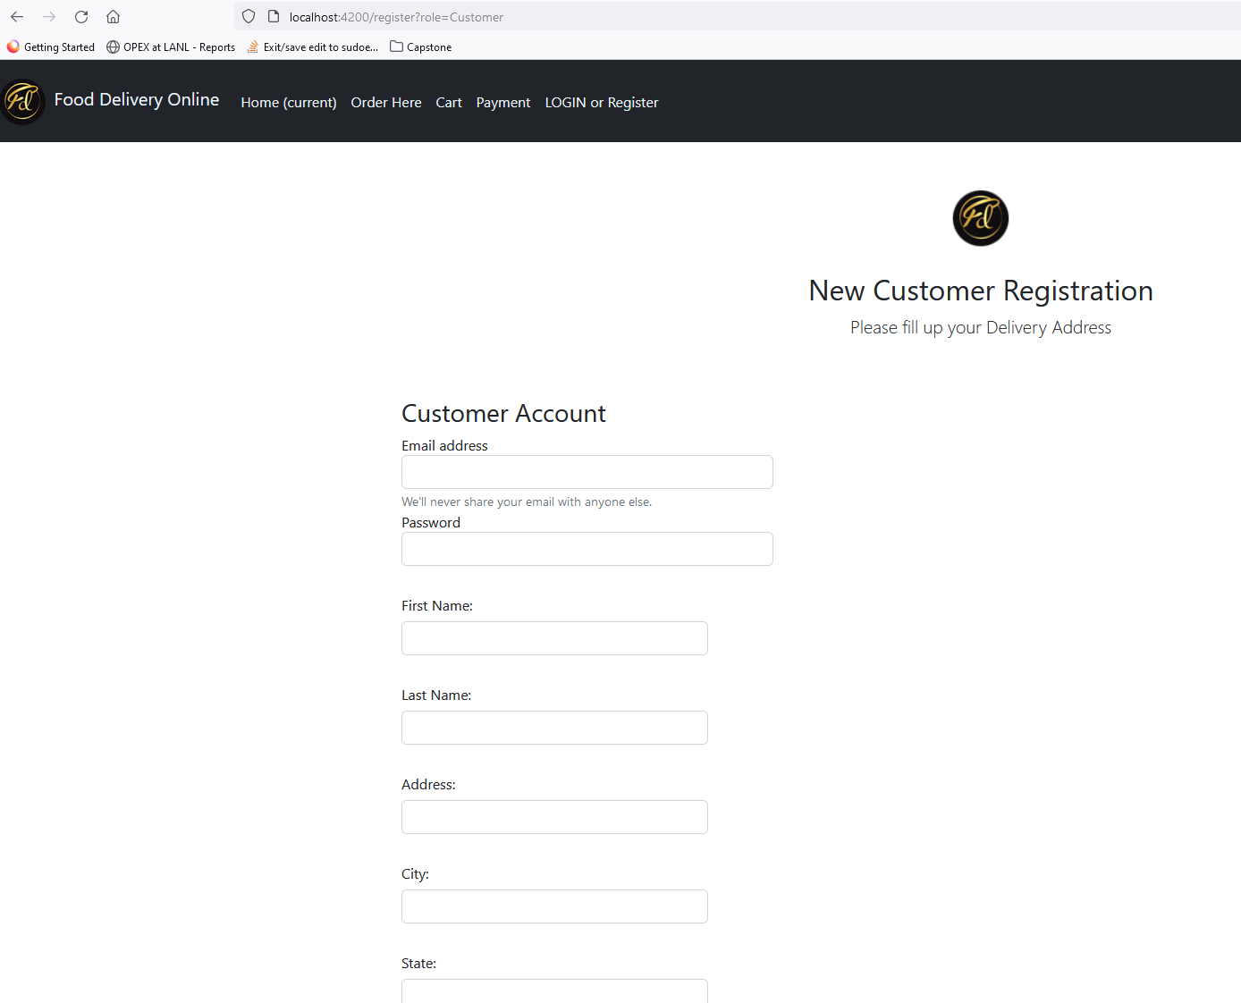

2.8 Register Admin

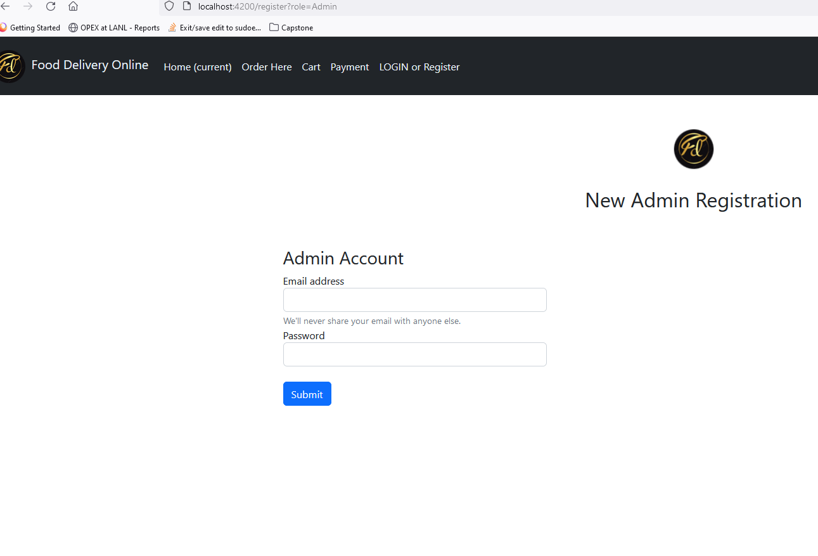

2.9. Admin Cuisine Maintenance

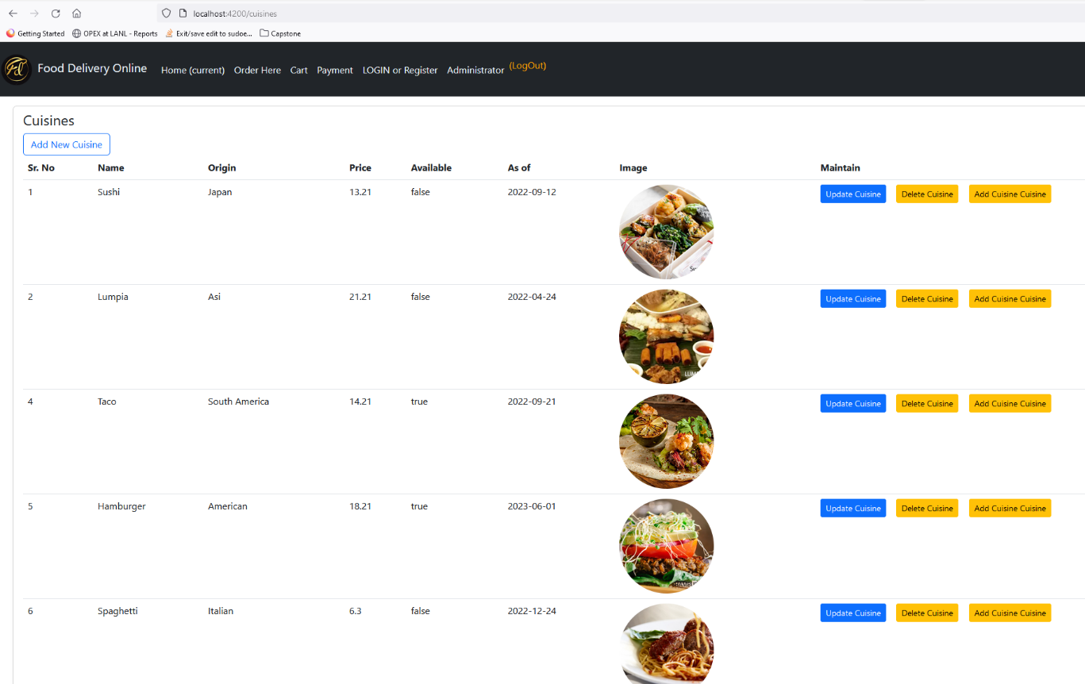

2.10 Admin Update Cuisine

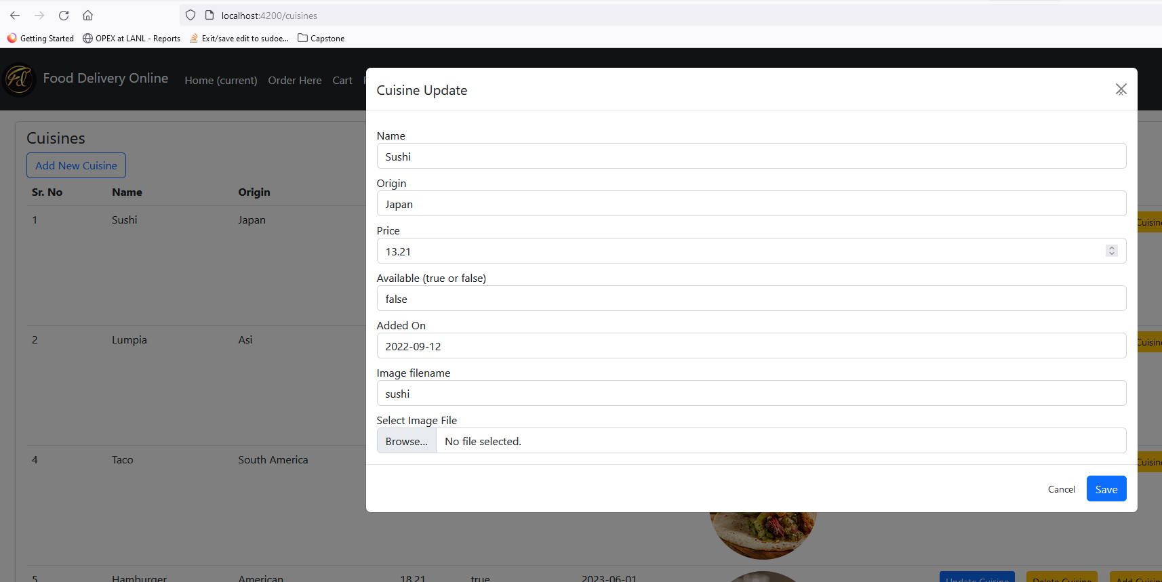

2.11. Admin Update Account Customer/Admin

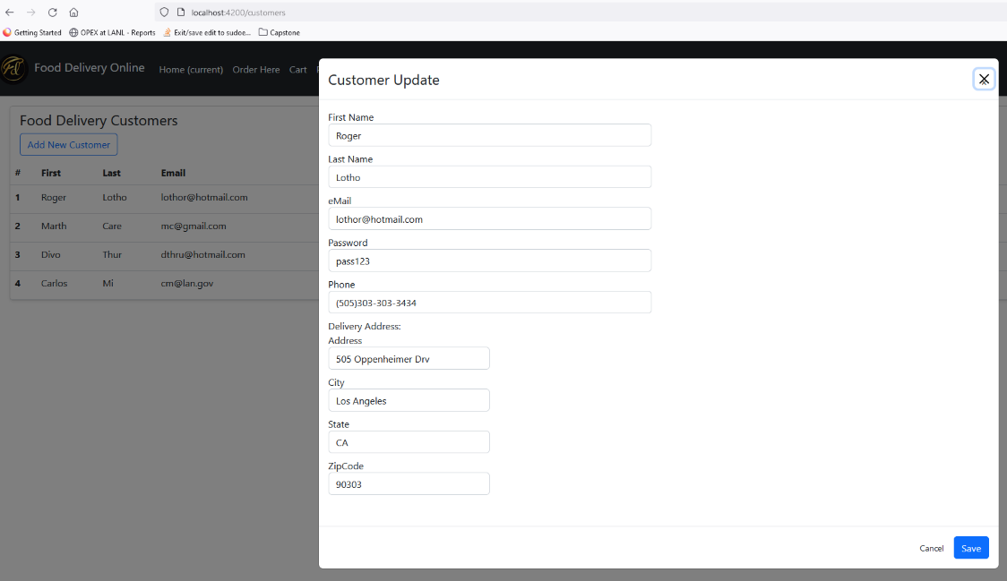

* 1. AuthGuard  
     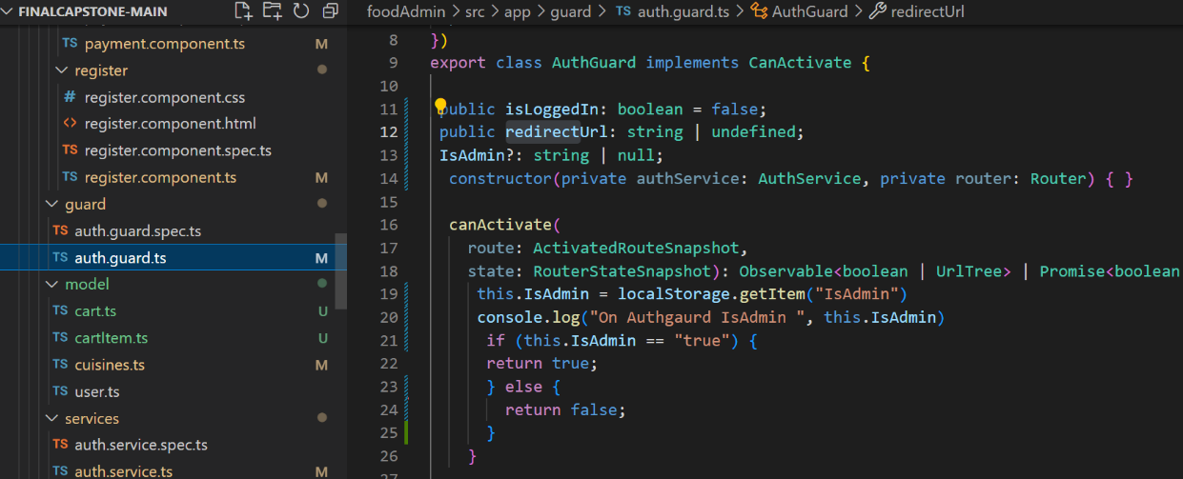

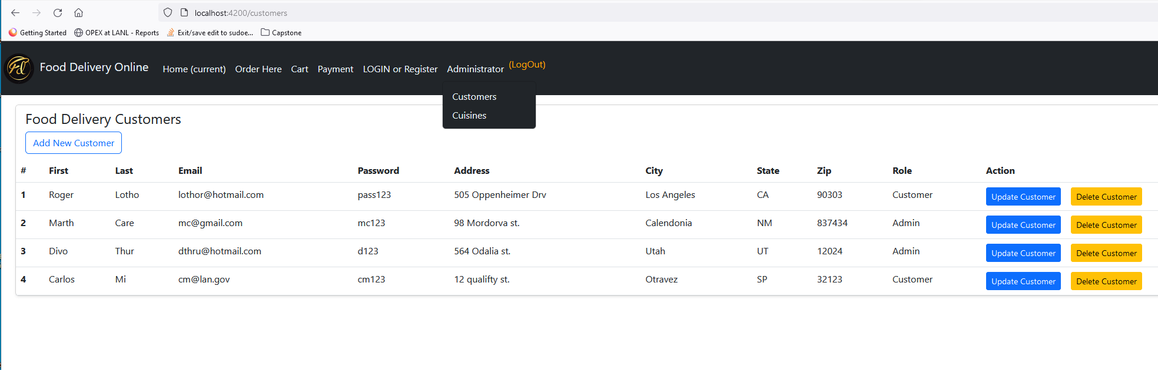

3. Task 3: SQL CRUD Commands, Primary and Foreign Key Relationship  
 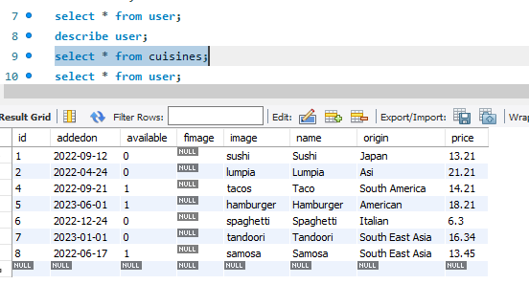

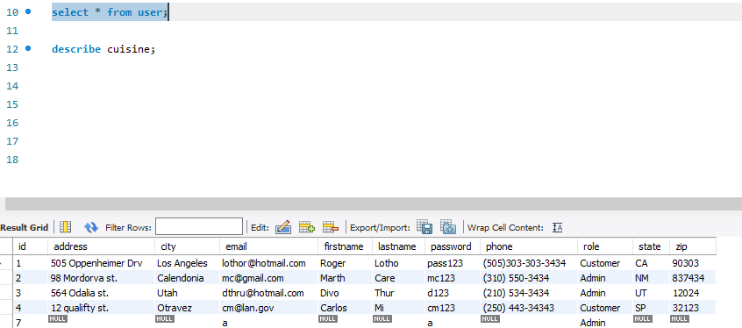

1. Task 4: SpringBoot Web Dependency, RestController, RequestMapping, Post and Get request
   1. SpringBoot Web Dependency  
      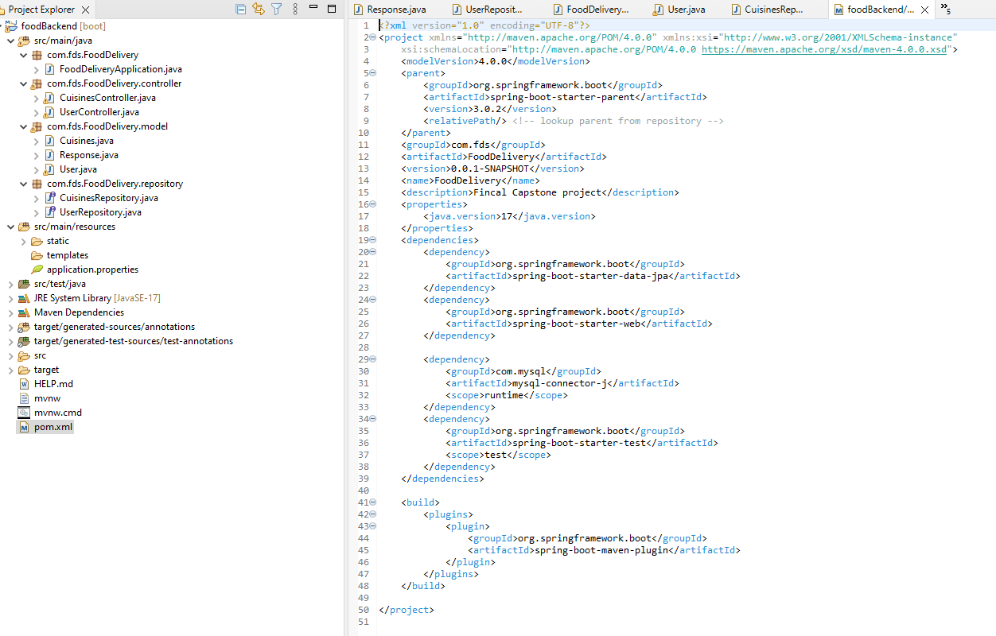
   2. Rest Controller

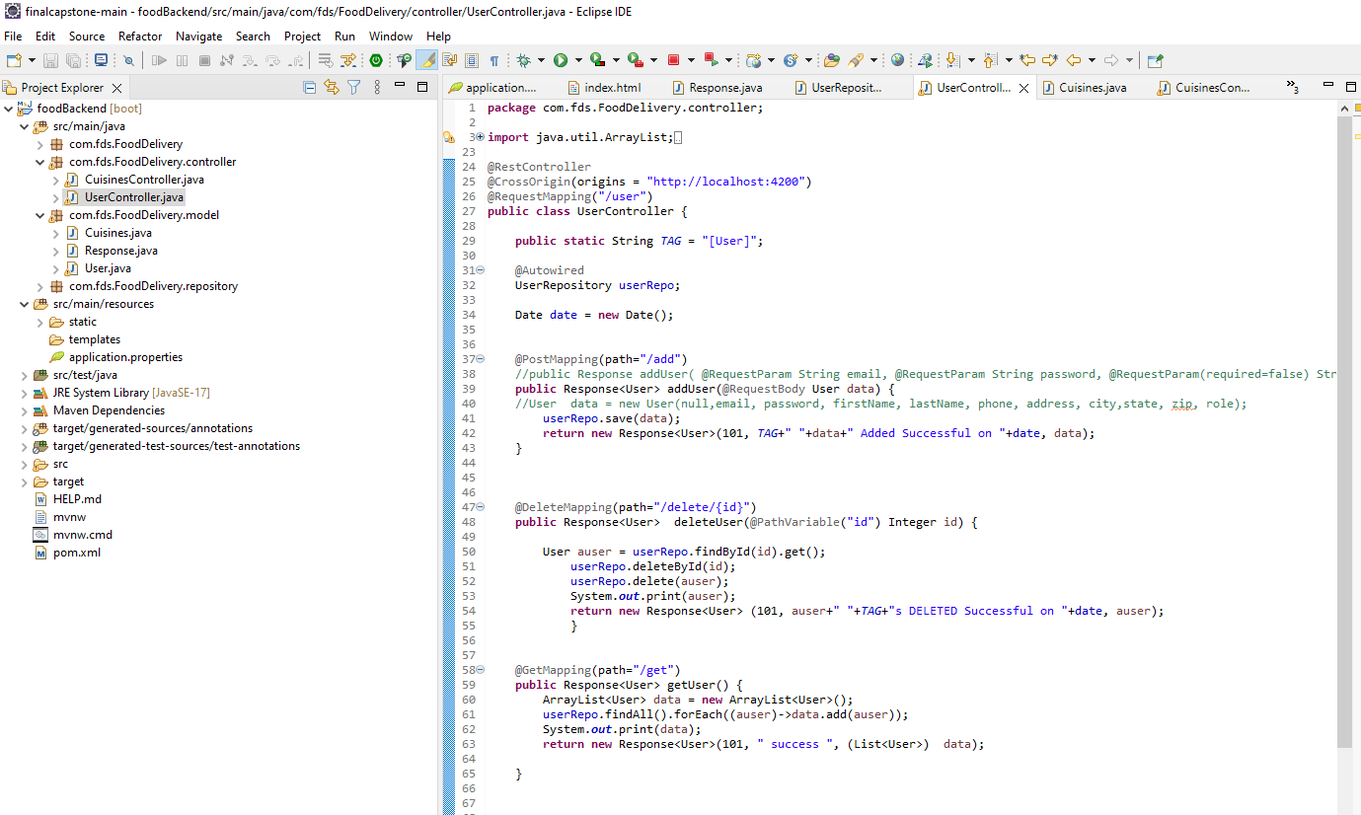

* 1. Request Mapping

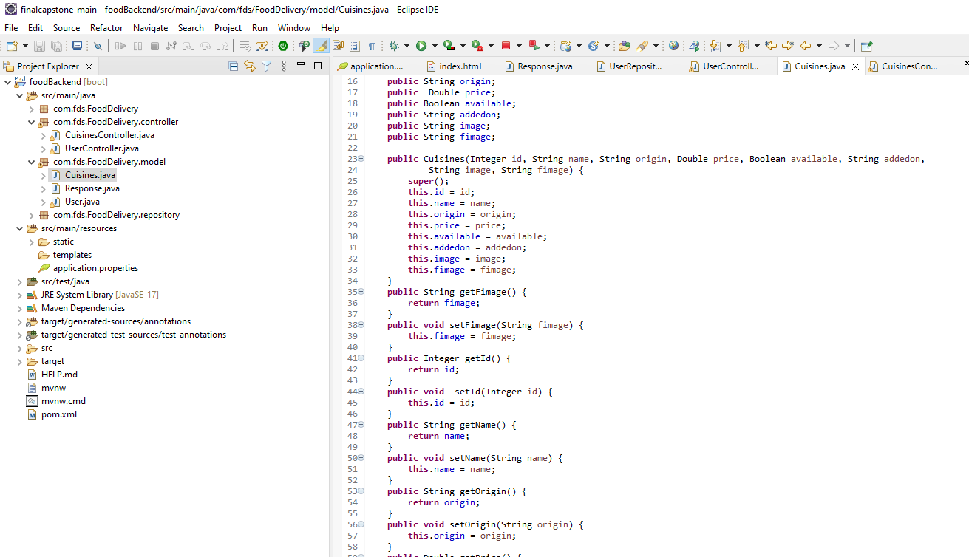

4.4. Post and Get Request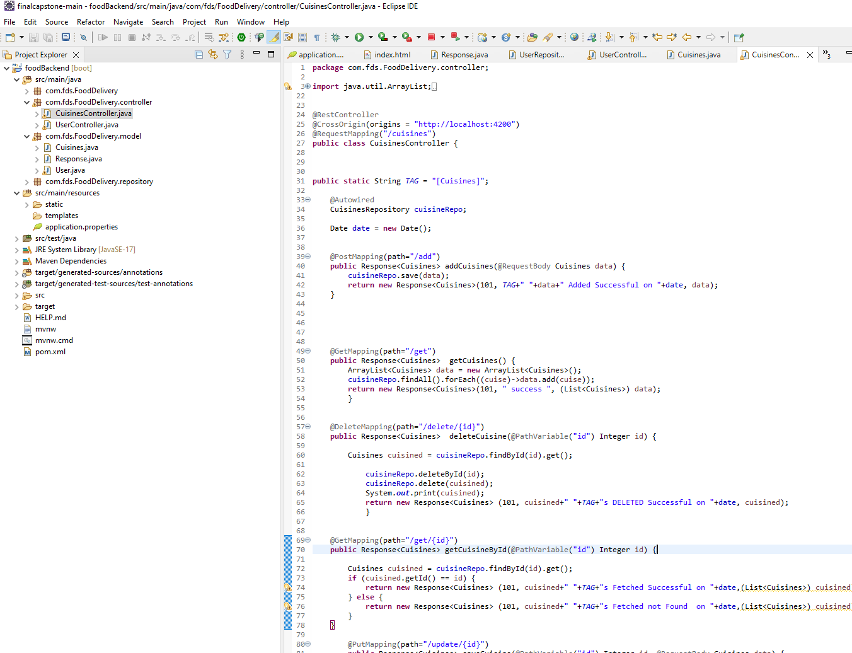  
4.5 Response model

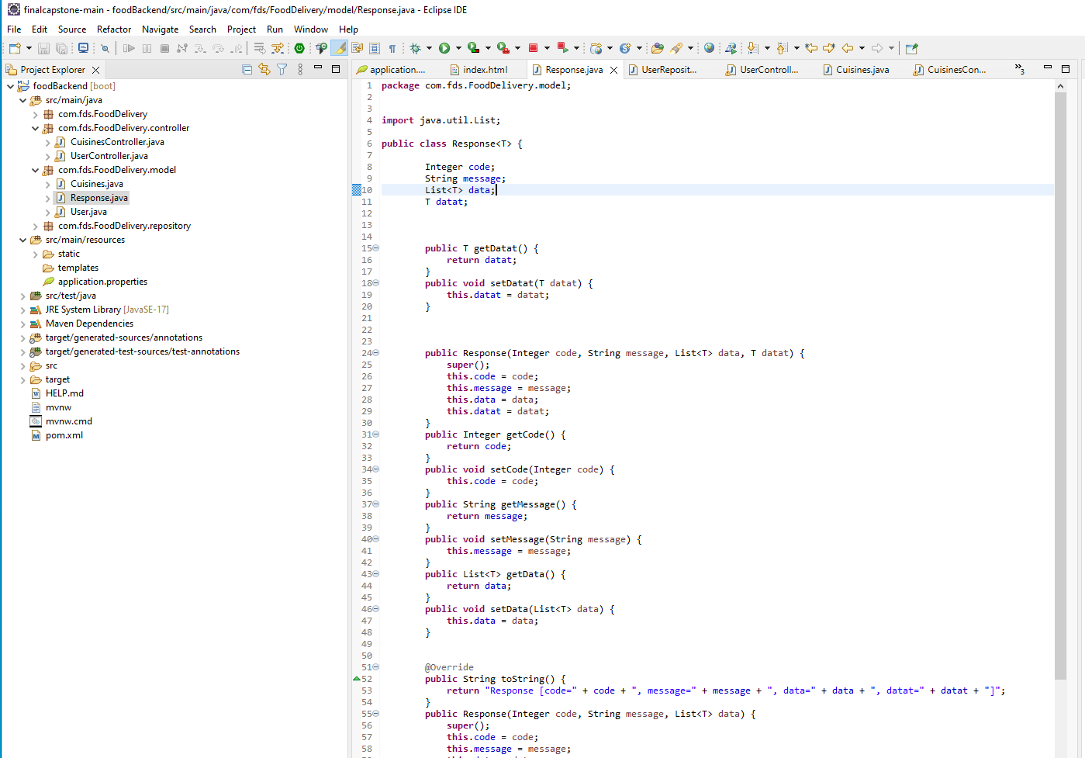

1. Task 5: Angular HTTP Client Library, HTTP Request Response, JSON  
     
   5.1. Base URL Cross Origin  
   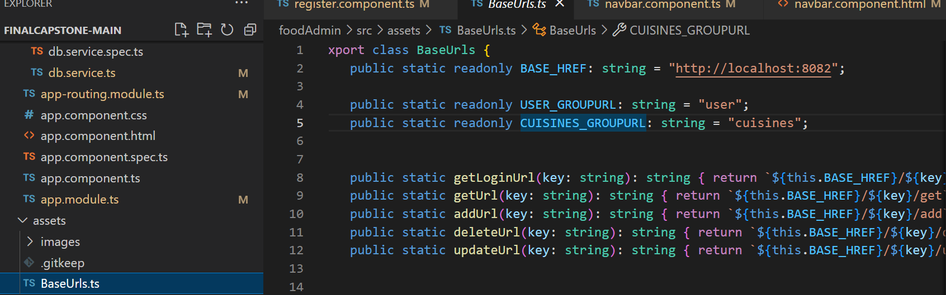  
   5.1 HTTP Request Response  
   

5.2. JSON  
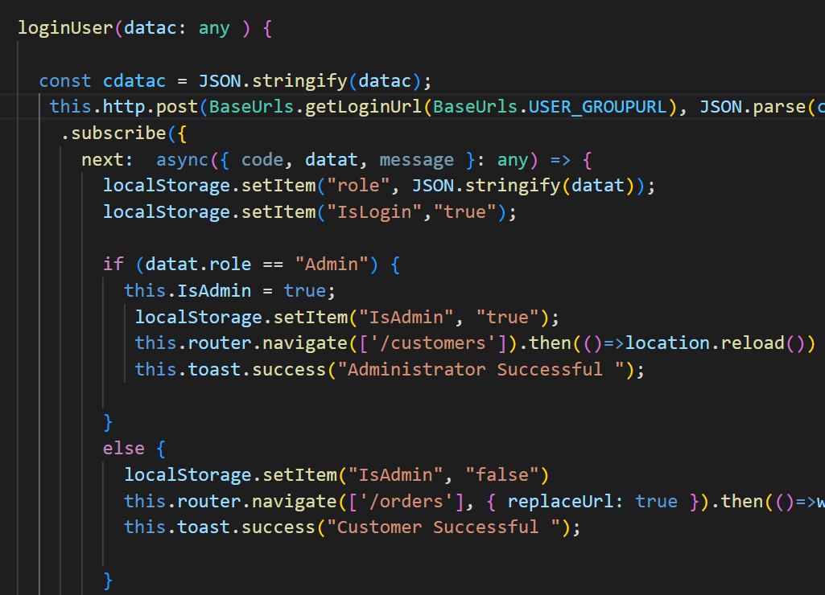

1. Task 6: Jenkinsfile stages and step declarations  
   1. Jenkins Stages

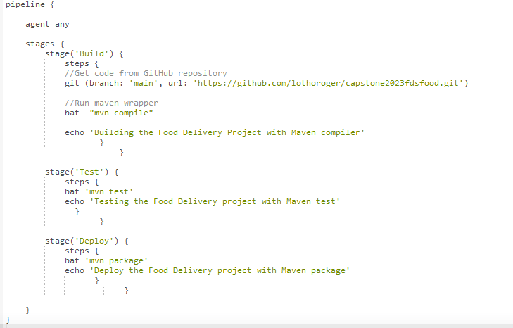

6.2 Build Success  
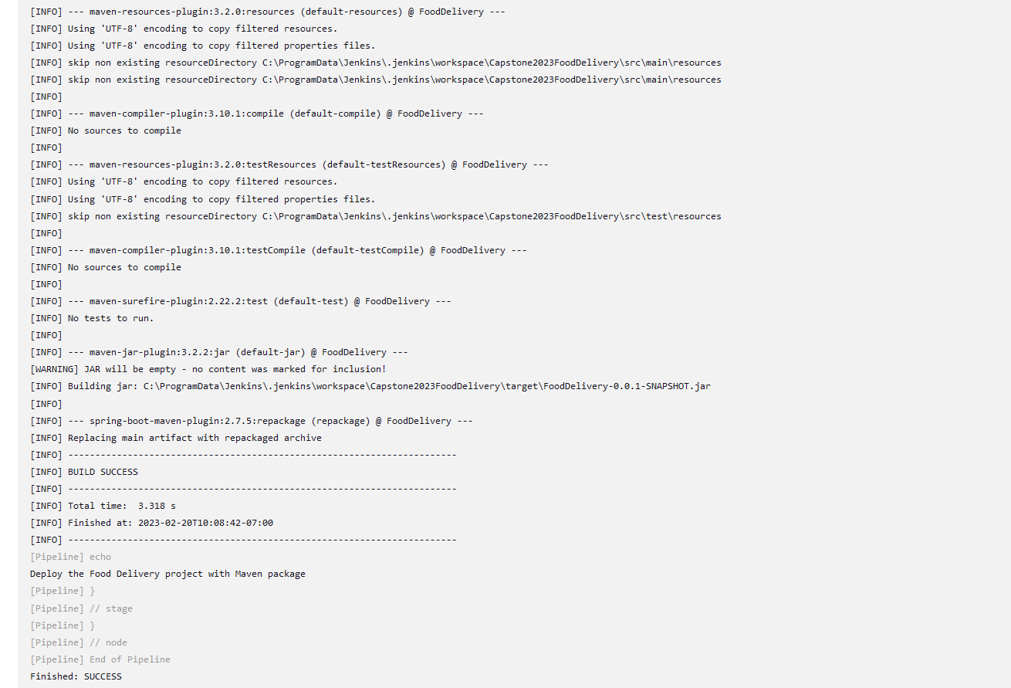

1. Task 7: Dockerfile and commands to assemble an image
   1. Docker Jenkins 9090:8080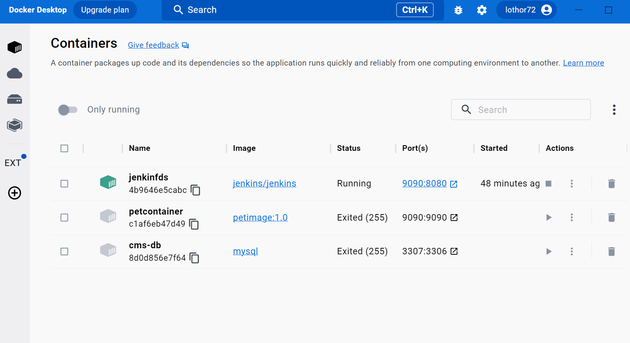
   2. Docker image 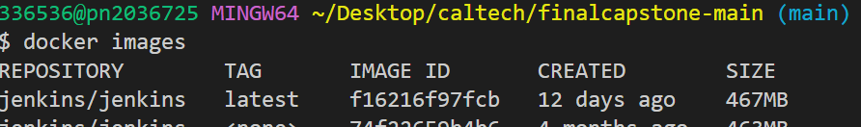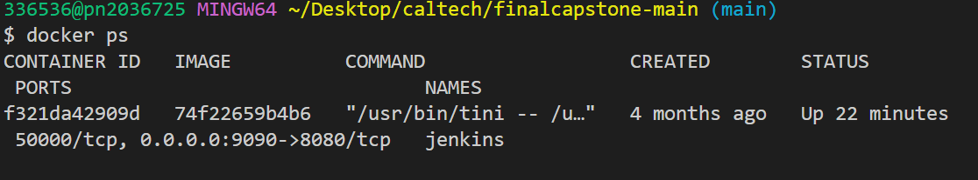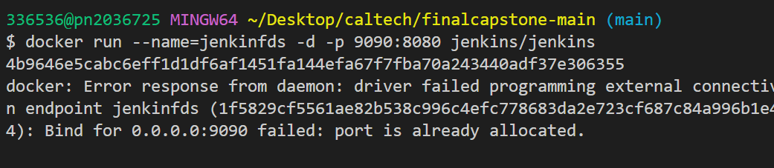

Docker file script

Configure the project with Docker File  
FROM openjdk:11  
RUN mkdir /app

COPY target/ /app  
WORKDIR /app

CMD java -jar FoodDelivery-0.0.1-SNAPSHOT.jar

--spring.config.name=application.properties

1. Task 8: Jenkins PipeLine Project Creating with git SCM

8.1 Jenkins pipeline script

pipeline {

agent any

stages {

stage('Build') {

steps {

sh 'chmod +x ./mvnw'

sh './mvnw compile'

echo 'Building the Food Delivery Project with Maven compiler'

}

}

stage('Test') {

steps {

sh './mvnw test'

echo 'Testing the Food Delivery project with Maven test'

}

}

stage('Deploy') {

steps {

sh './mvnw package'

echo 'Deploy the Food Delivery project with Maven package'

} } } }

* 1. Docker Jenkins 9090:8080 Git SCM

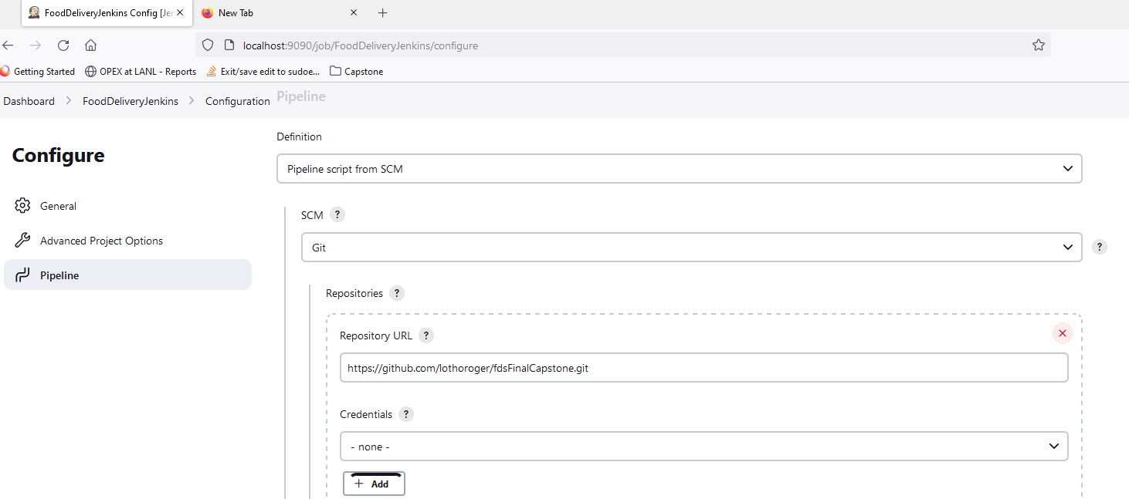

8.3 Build Stage

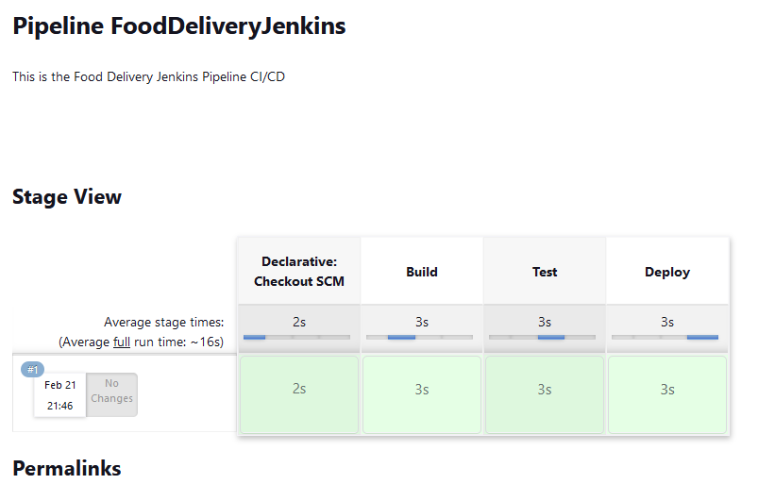

1. Task 9: AWS, EC2, SSH/Cloud Shell Connection, Tool Configuration

Create and Launch AWS EC2 Instance  
9.1.1 Create Key Pair -FDS keypair   
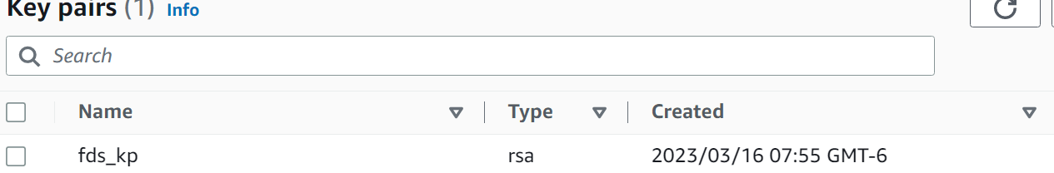

* + 1. Security Group – FDS_SG set inbound allow

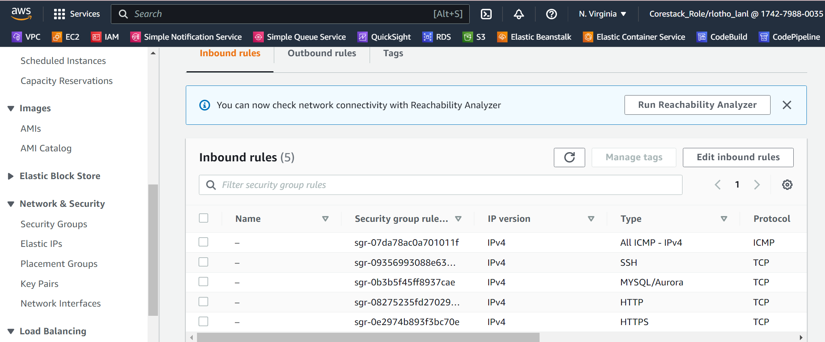

* + 1. RDS setup Database

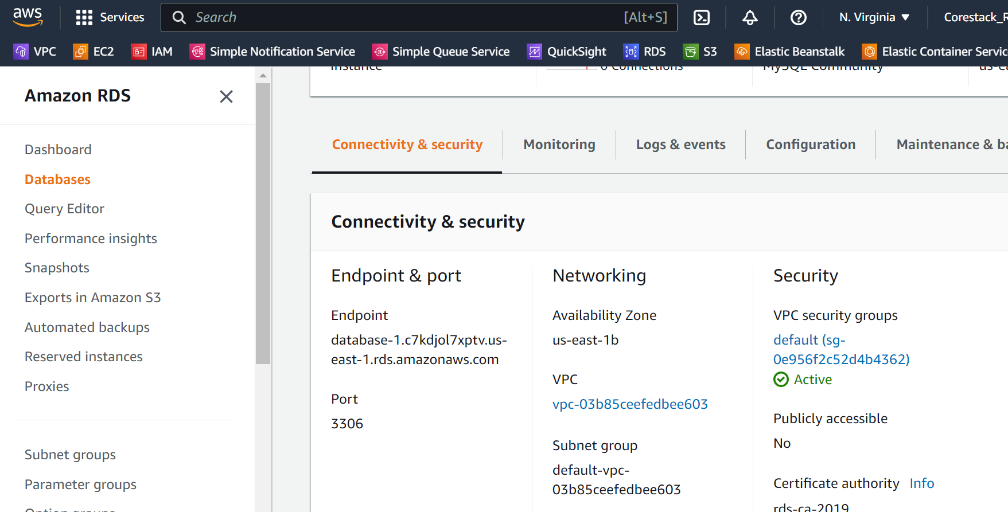

9.1.3.1 Connect to AWS RDS from AWS cli, create DB  
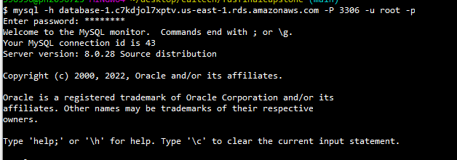  
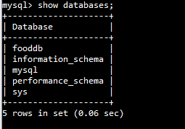

9.3.1.2 Connect project to AWS RDS and build Jar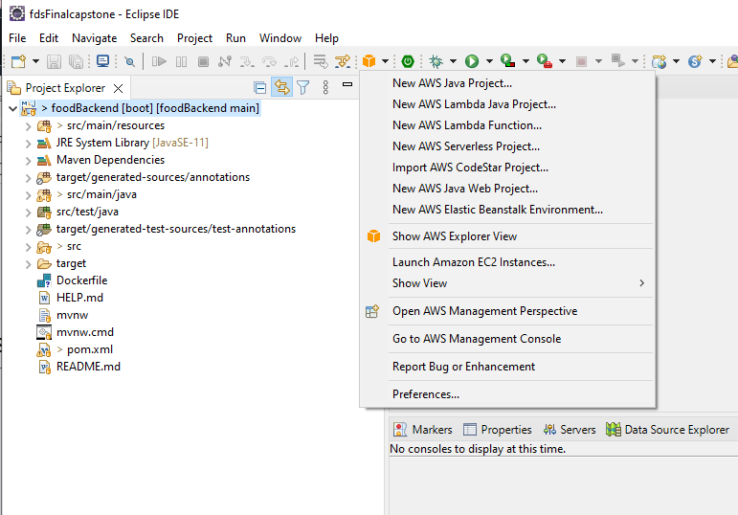

Springboot AWS RDS connection  
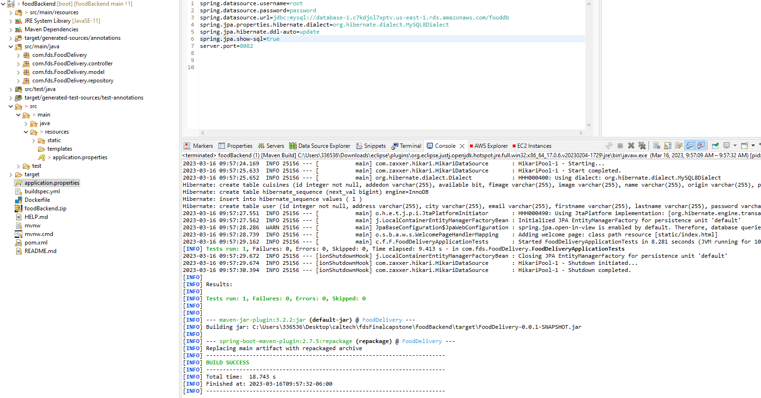

AWS CodePipeline  
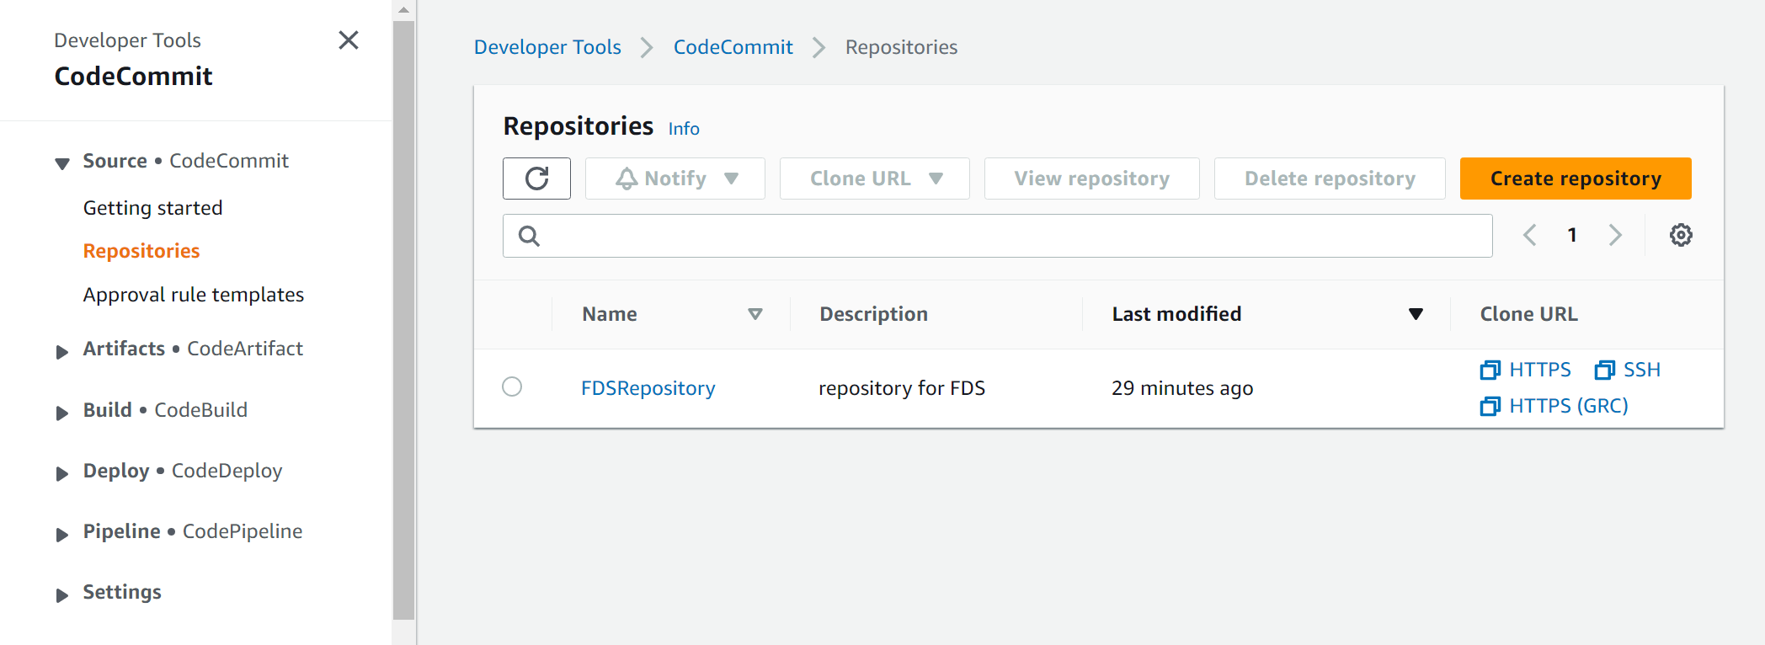

* 1. Create new Repository : AWS CodeCommit git-remote  
     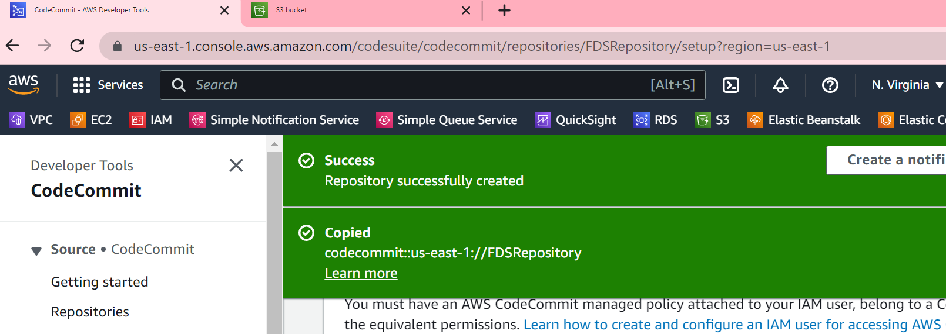

9.3.1 **git-remote-codecommit us-east-1://FDSRepository**

9.3.2 Clone URL GRC   
AWS cli, git status, git commit, git push

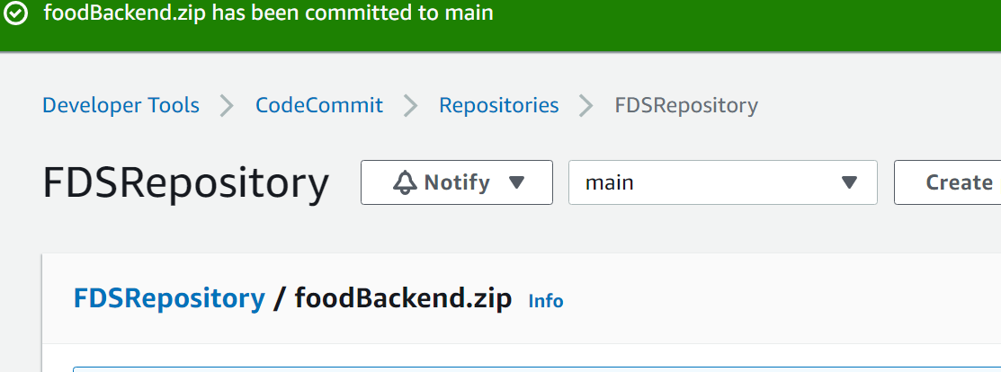  
9.4 Artifacts: AWS Code Artifacts

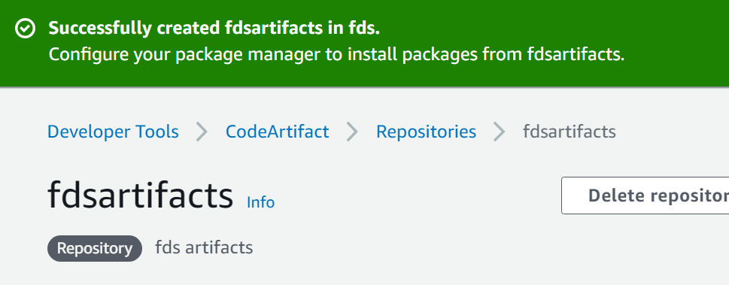

9.5 CodeBuild: AWS CodeBuild

9.5.1. AWS S3 service: Bucket

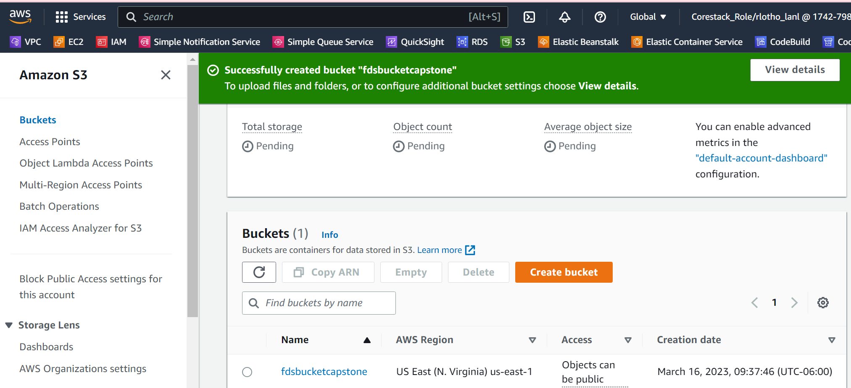

9.5.2. Set AWS CodeCommit, BuildSpec, Artifacts, S3 Bucket

9.5.2.1 S3 bucket  
 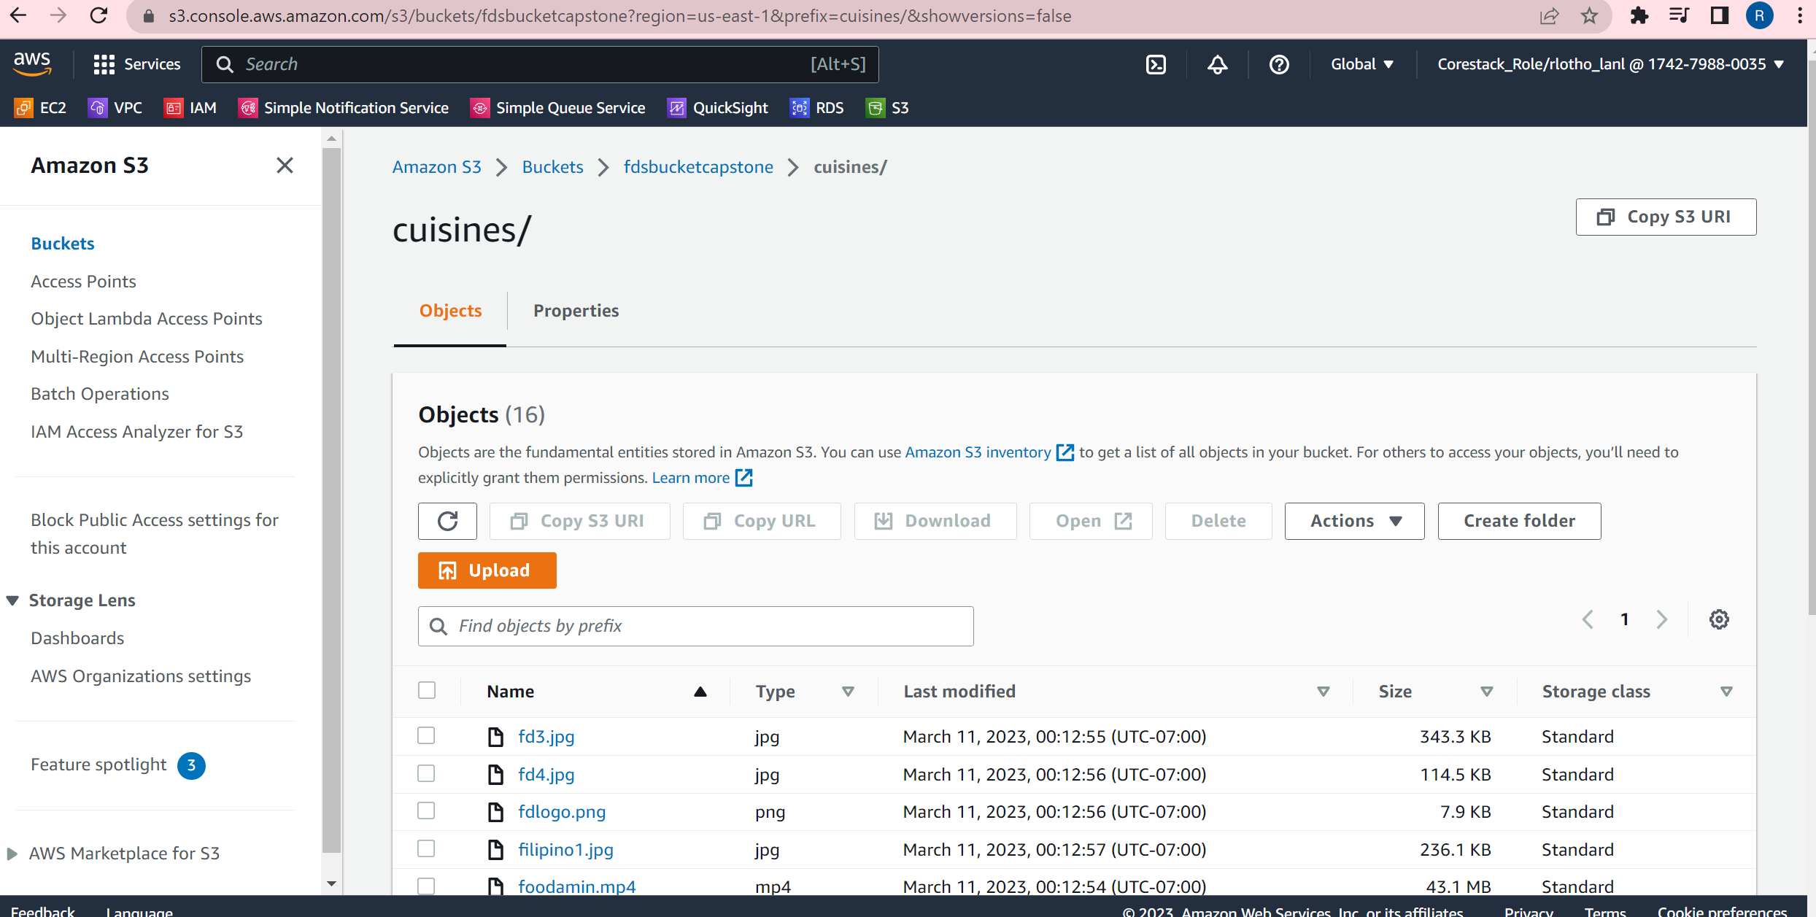  
 9.5.2.2 Setup Build Project

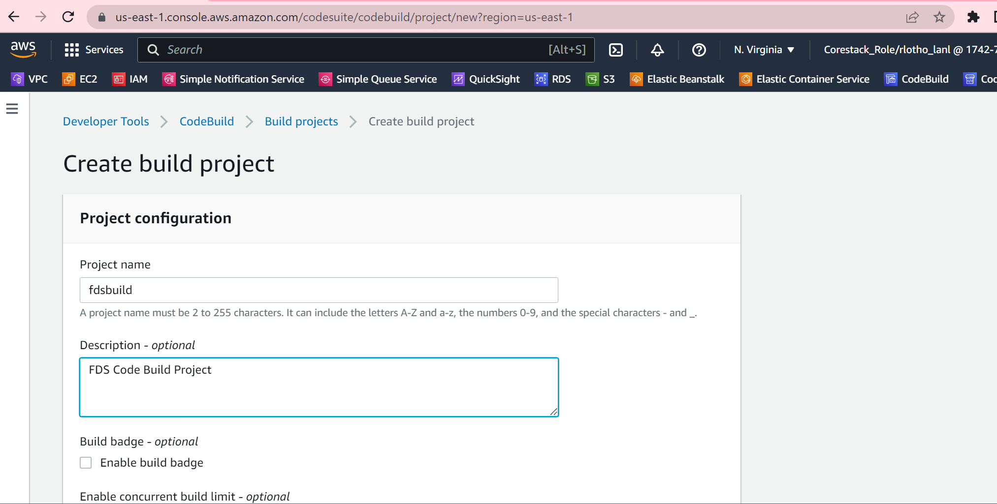

9.6. AWS ElasticBeanstalk

9.6.1. Install openjdk  
 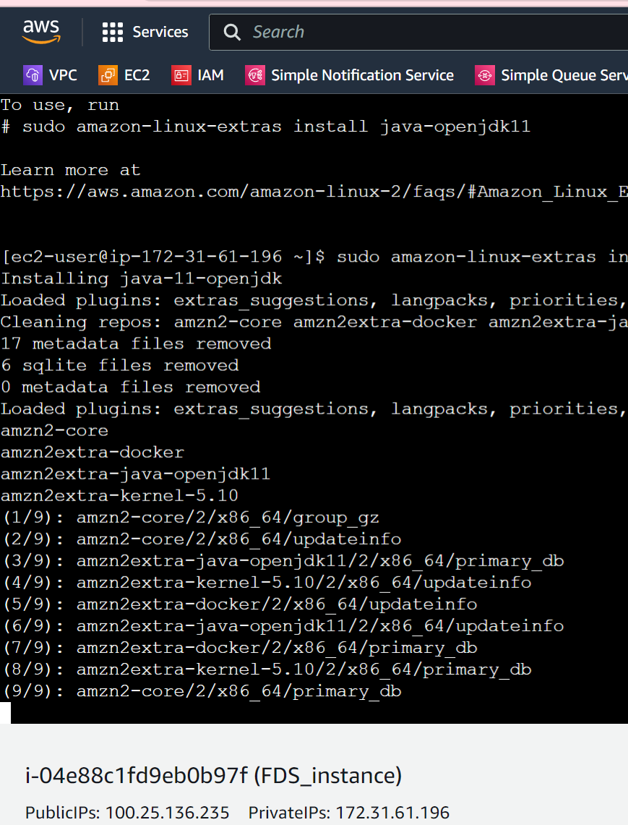  
9.6.2 Secure copy JAR to AWS instance image  


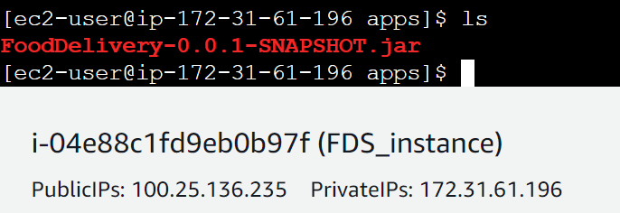  
 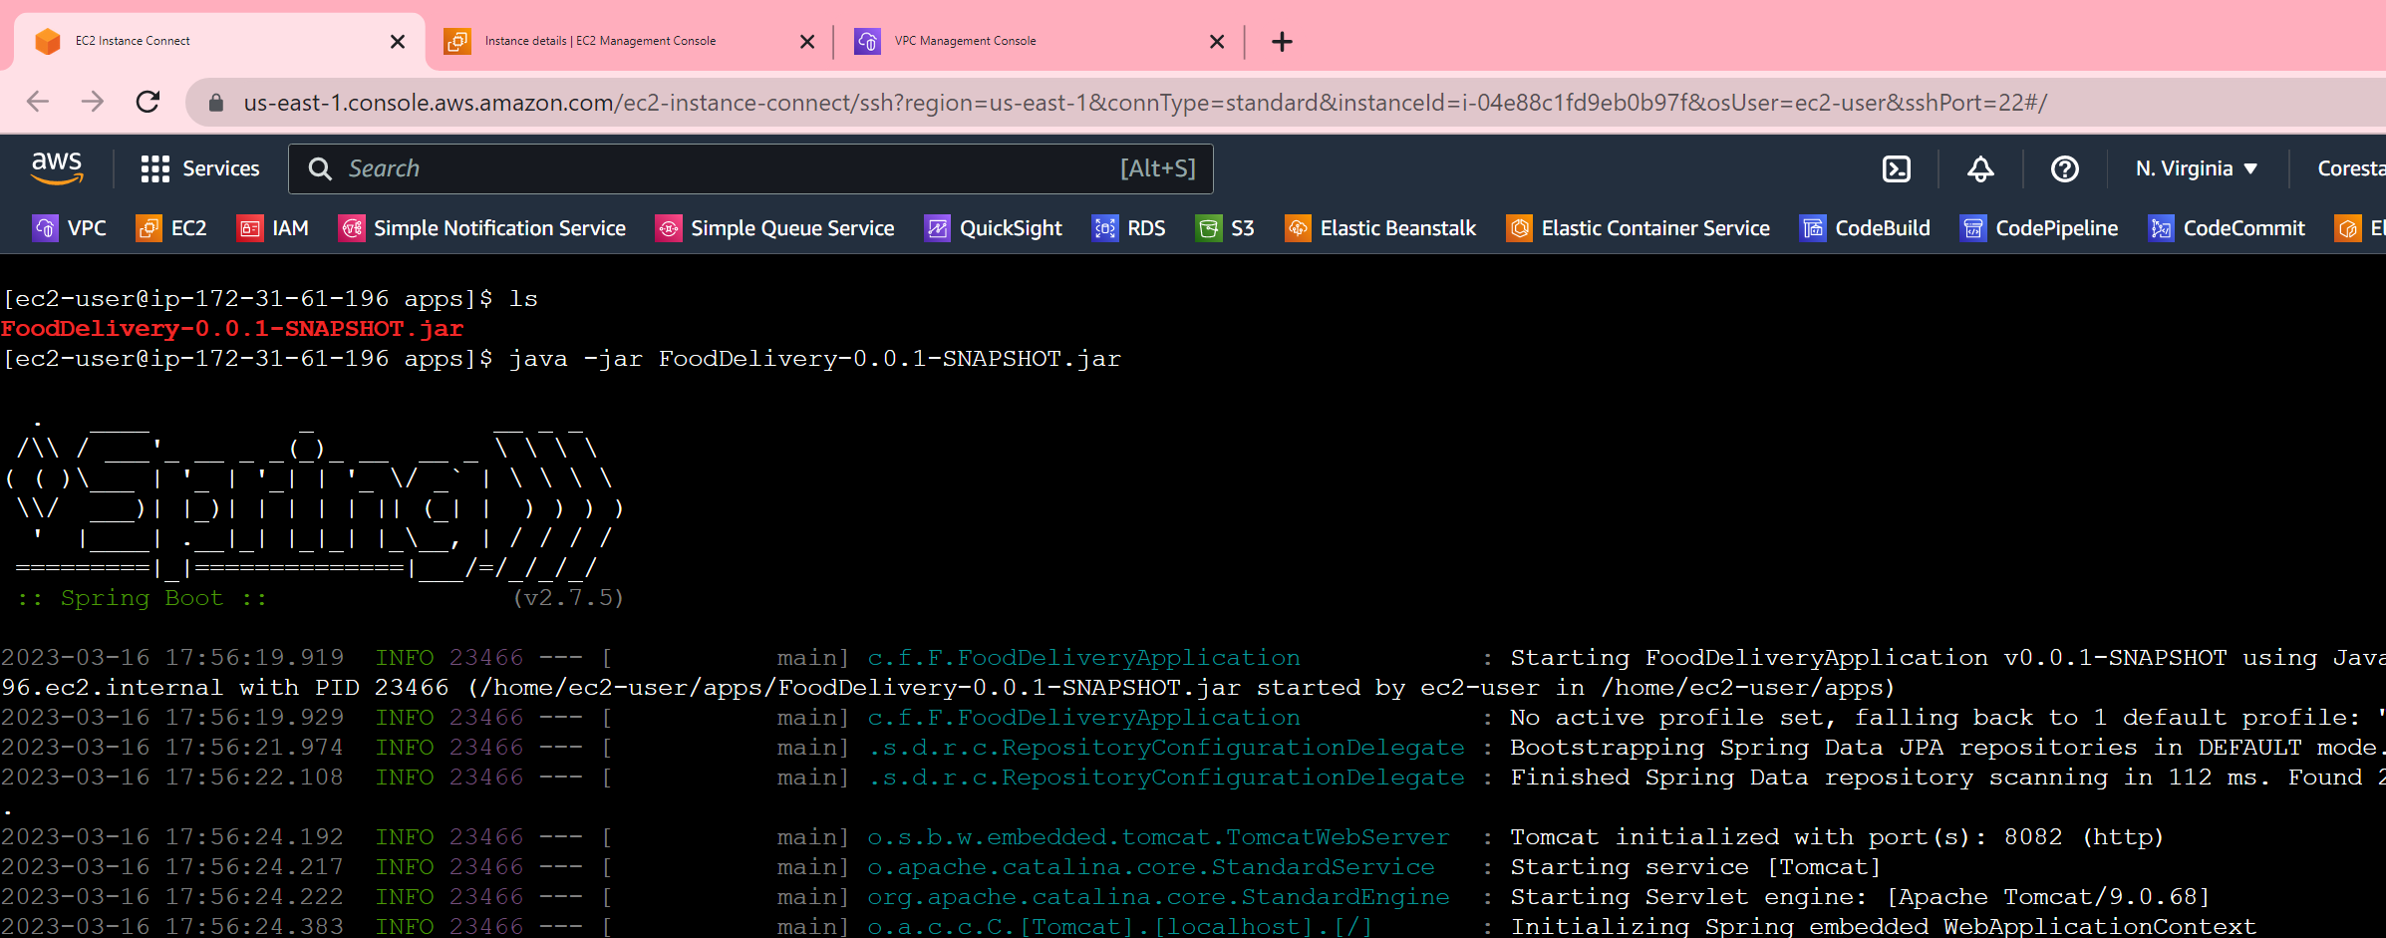

9.6.3 EC2 Instance – FDS_Instance  
 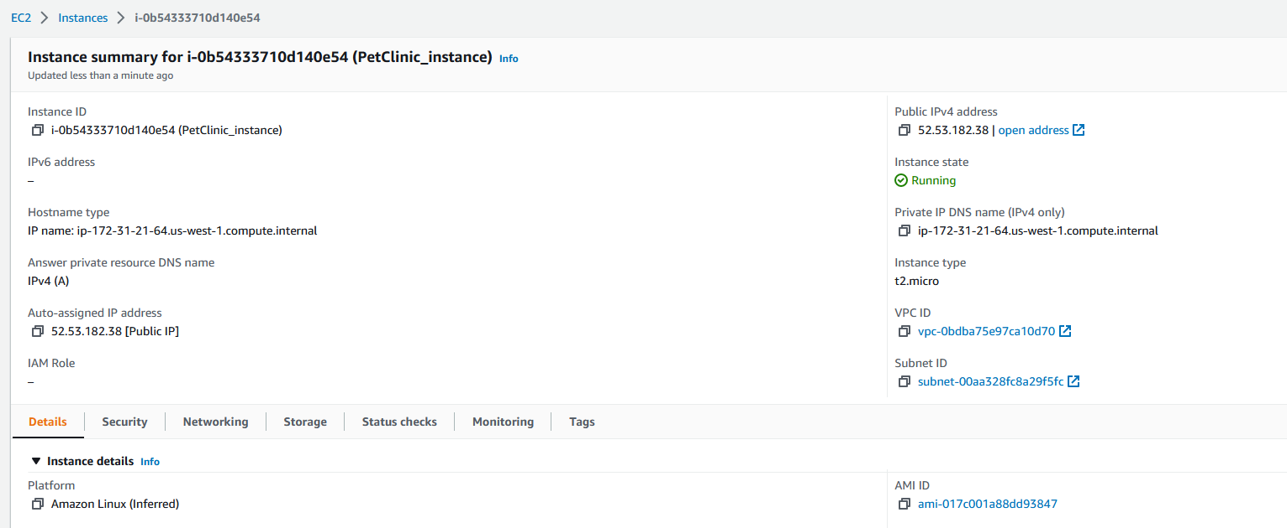

* + 1. Configure EC2 Instance with Docker  
       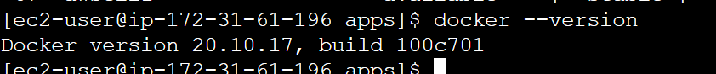

9.6.5 PostMan Add/Display records from AWS EC2  
 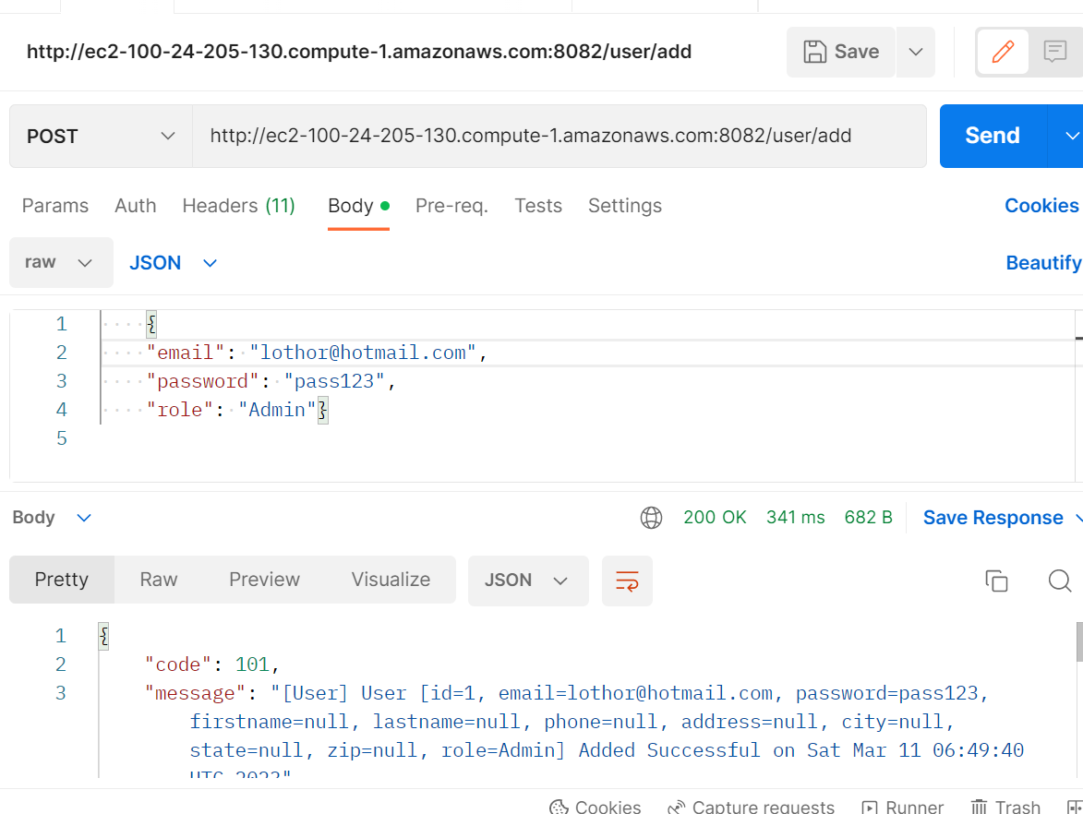  
 9.6.6 AWS EC2 console  
 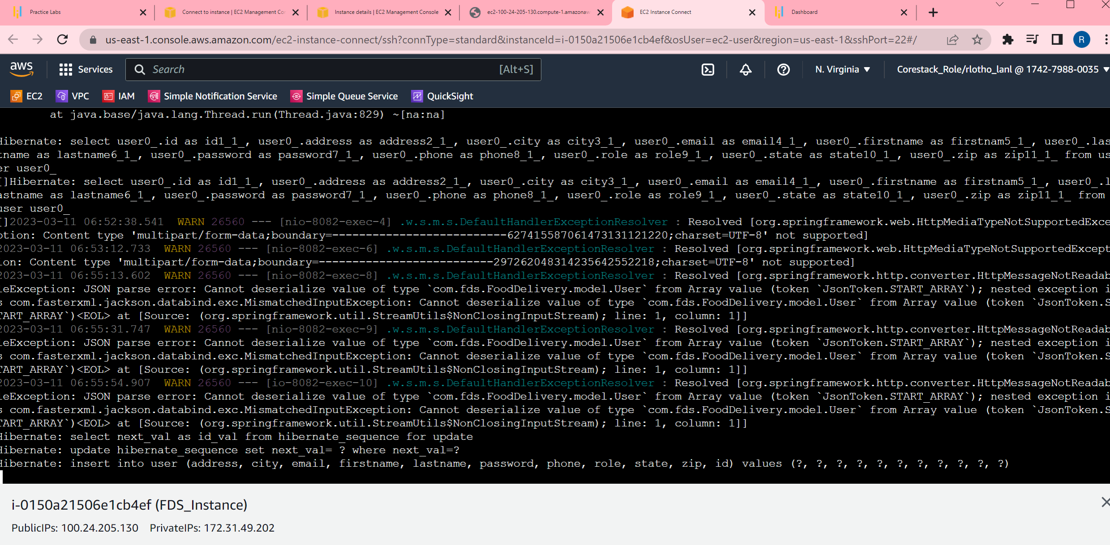

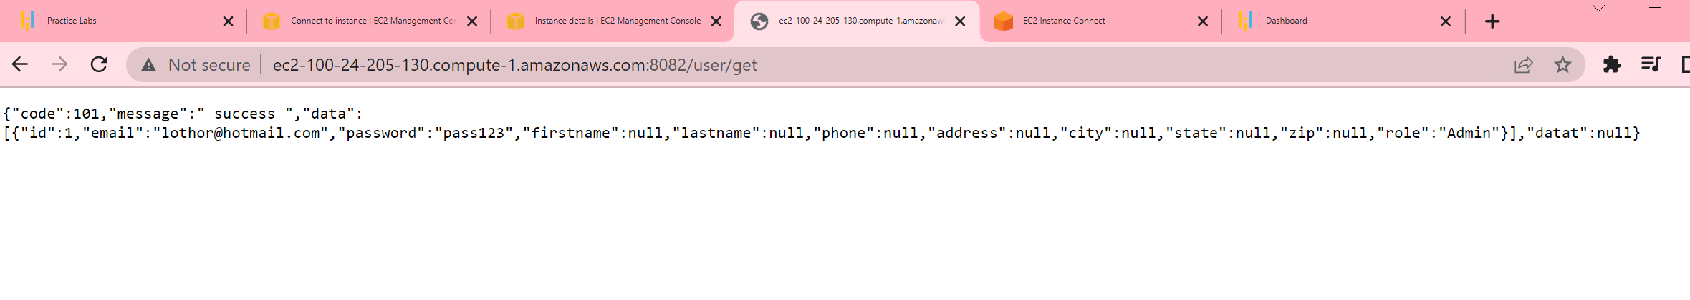

9.6.7 AWS EC2 Instance

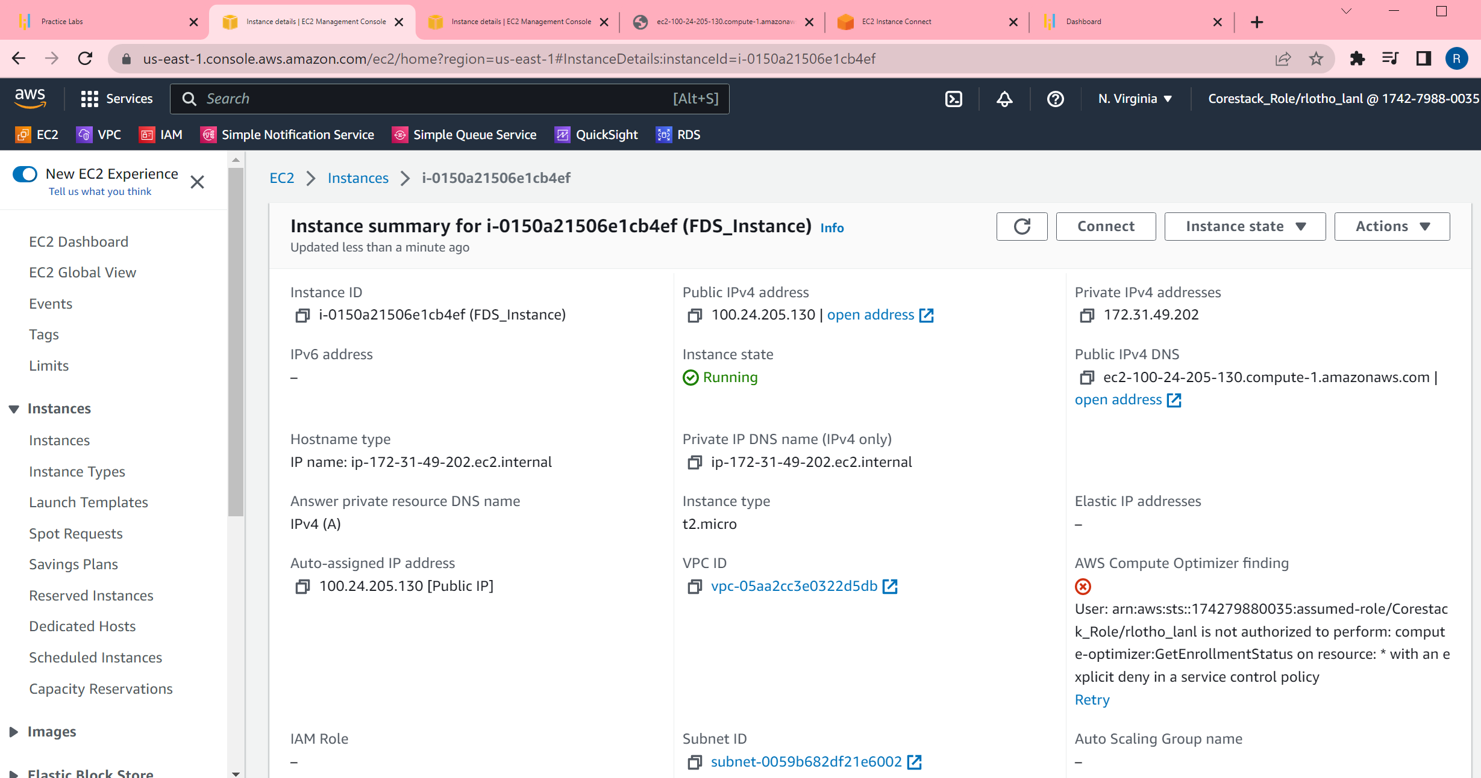

9.6.8 AWS Elastic Beanstalk

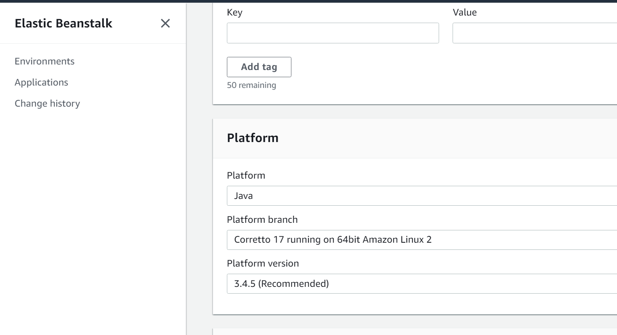  
 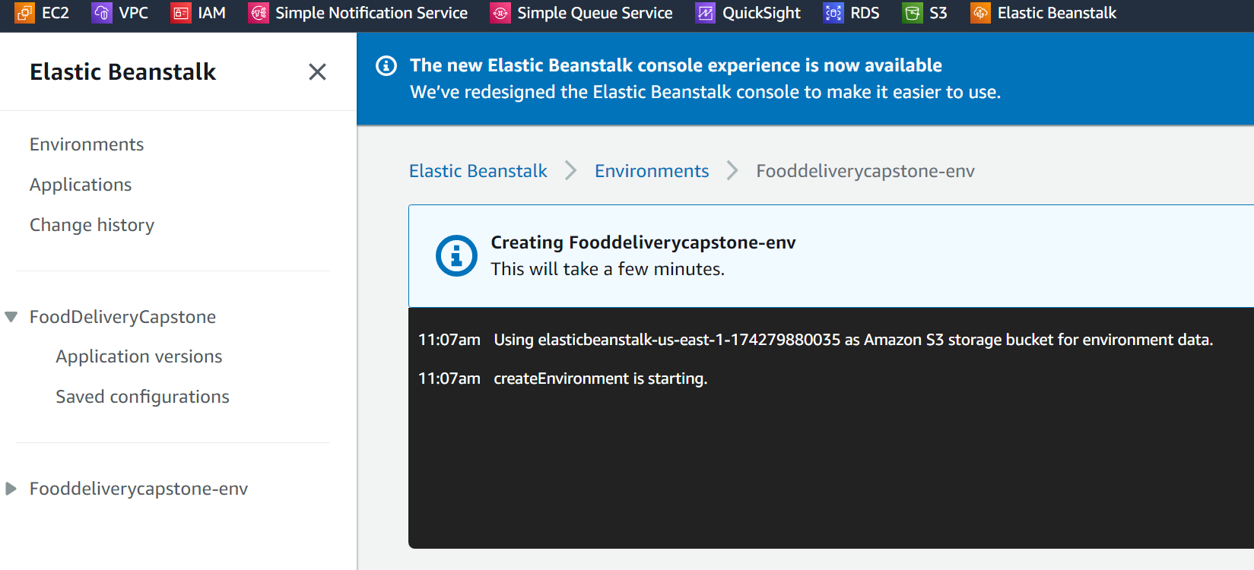

10. Task 10 Jenkins Pipeline Build

